Laporan Kegiatan Modul 8

Nama :DRISKA IAN P

NIM :L200160016

Kelas :E

Quarto Modulo

1. Percobaan Alert

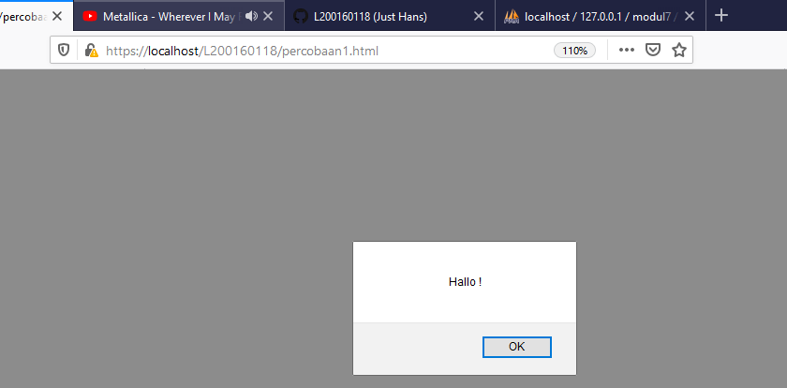

1. MouseOver

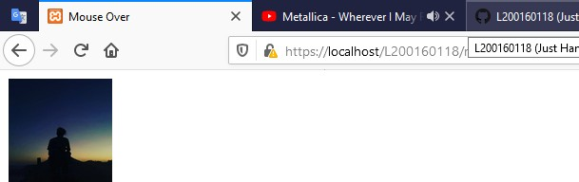

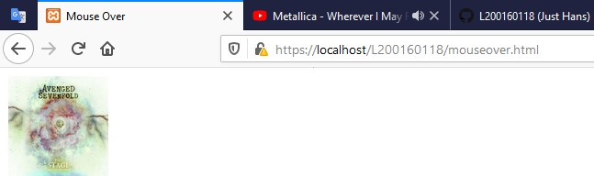

1. Character Counter

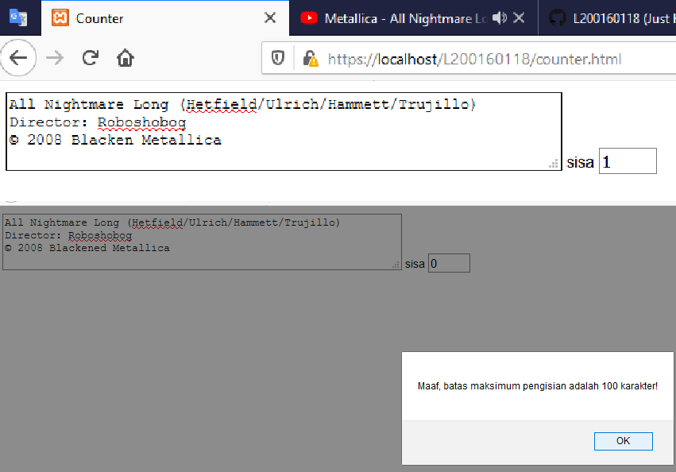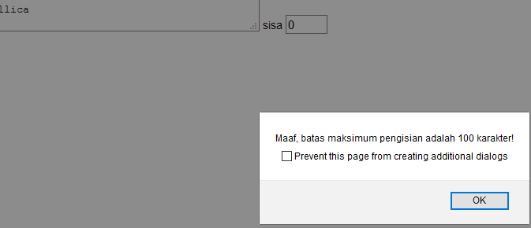

1. Kalulator

